IET DEPARTMENT



Data Structure and Algorithm
Lab Manual
Lab 10: Recursion and Searching Algorithms
Objectives:
- Understand and implement Linear searching
- Understand and implement Binary searching
- Understand recursion
Introduction
Searching is an operation or a technique that helps finds the place of a given element or value in the list. Any search is said to be successful or unsuccessful depending upon whether the element that is being searched is found or not. Some of the standard searching technique that is being followed in the data structure is listed below:
- Linear Search or Sequential Search
- Binary Search

Activity Time boxing

Task No. | Activity Name | Activity time | Total Time
1 | Lab Manual Lecture | 20 mins
2. | Example | 10 mins
3 | Walkthrough Tasks | 10 mins
4. | Lab Tasks | 9100 mins
5. | Evaluation | 30 mins | 170 mins

Concept Map
Recursion: The process in which a function calls itself directly or indirectly is called recursion and the corresponding function is called as recursive function. Using recursive algorithm, certain problems can be solved quite easily. Examples of such problems are Towers of Hanoi (TOH), Inorder/Preorder/Postorder Tree Traversals, DFS of Graph, etc. The idea is to represent a problem in terms of one or more smaller problems and add one or more base conditions that stop the recursion. For example, we compute factorial n if we know factorial of (n-1). The base case for factorial would be n = 0. We return 1 when n = 0.
There are two types of recursion
- Direct recursion: A function fun is called direct recursive if it calls the same function fun.
- Indirect recursion: A function fun is called indirect recursive if it calls another function say fun_new and fun_new calls fun directly or indirectly.
Properties: A recursive function can go infinite like a loop. To avoid infinite running of recursive function, there are two properties that a recursive function must have
- Base criteria − There must be at least one base criteria or condition, such that, when this condition is met the function stops calling itself recursively.
- Progressive approach − The recursive calls should progress in such a way that each time a recursive call is made it comes closer to the base criteria.
Implementation
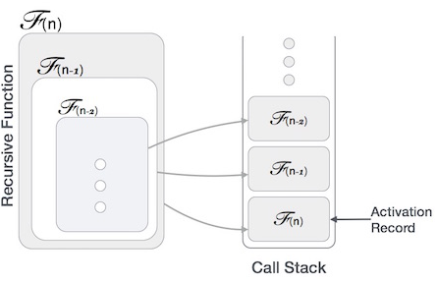
Many programming languages implement recursion by means of stacks. Generally, whenever a function (caller) calls another function (callee) or itself as callee, the caller function transfers execution control to the callee. This transfer process may also involve some data to be passed from the caller to the callee. This implies, the caller function has to suspend its execution temporarily and resume later when the execution control returns from the callee function. Here, the caller function needs to start exactly from the point of execution where it puts itself on hold. It also needs the exact same data values it was working on. For this purpose, an activation record (or stack frame) is created for the caller function. This activation record keeps the information about local variables, formal parameters, return address and all information passed to the caller function.

Factorial by recursion (Code)
def factorial(n):
if n == 0:
return 1
else:
return n * factorial(n-1)
5! 5*4*3*2*1
0! 1
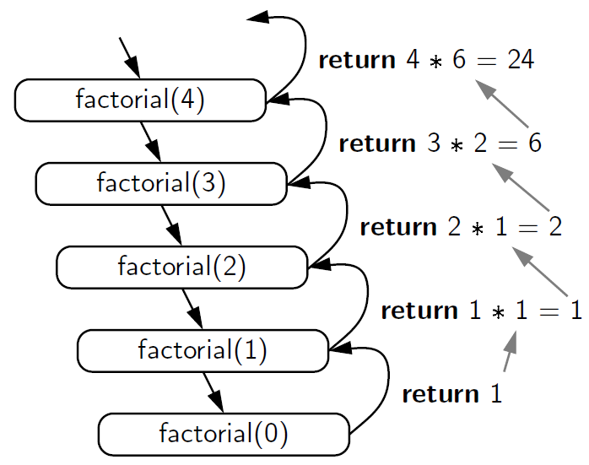
Searching Algorithms
- Linear Search
This is the simplest method for searching. In this technique of searching, the element to be found in searching the elements to be found is searched sequentially in the list. This method can be performed on a sorted or an unsorted list (usually arrays). In case of a sorted list searching starts from 0th element and continues until the element is found from the list or the element whose value is greater than (assuming the list is sorted in ascending order), the value being searched is reached.
Its best execution time is one, whereas the worst execution time is n, where n is the total number of items in the search array.
Time Complexity
- Best- case complexity = O(1) occurs when the search element is present at the first element in the search array.
- Worst- case complexity = O(n) occurs when the search element is not present in the set of elements or array.
- Average complexity = O(n) is referred to when the element is present somewhere in the search array.
Code:
public static int search(int arr[], int x)
{
int n = arr.length;
for (int i = 0; i < n; i++)
{
if (arr[i] == x)
return i; }
return -1; }

// Driver code
public static void main(String args[])
{
int arr[] = { 2, 3, 4, 10, 40 };
int x = 10;

// Function call
int result = search(arr, x);
if (result == -1)
System.out.print(
"Element is not present in array");
else
System.out.print("Element is present at index "
+ result);
}

- Binary Search
Binary search is a very fast and efficient searching technique. It requires the list to be in sorted order. In this method, to search an element you can compare it with the present element at the center of the list. If it matches, then the search is successful otherwise the list is divided into two halves: one from the 0th element to the middle element which is the Center element (first half) another from the Center element to the last element (which is the 2nd half) where all values are greater than the Center element.
The searching mechanism proceeds from either of the two halves depending upon whether the target element is greater or smaller than the central element. If the element is smaller than the central element, then searching is done in the first half, otherwise searching is done in the second half.
- Run-time complexity = O(log n)
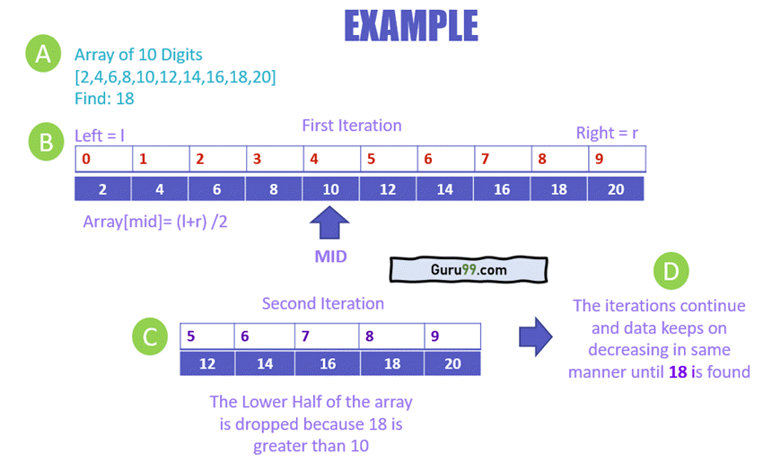
Code
class BinarySearch {
// Returns index of x if it is present in arr[l..
// r], else return -1
int binarySearch(int arr[], int l, int r, int x)
{
if (r >= l) {
int mid = l + r / 2;
// If the element is present at the middle itself
if (arr[mid] == x)
return mid;
// If element is smaller than mid, then it can only be present in left subarray
if (arr[mid] > x)
return binarySearch(arr, l, mid - 1, x);

// Else the element can only be present
// in right subarray
return binarySearch(arr, mid + 1, r, x);
}

// We reach here when element is not present
// in array
return -1;
}

// Driver method to test above
public static void main(String args[])
{
BinarySearch ob = new BinarySearch();
int arr[] = { 2, 3, 4, 10, 40 };
int n = arr.length;
int x = 10;
int result = ob.binarySearch(arr, 0, n - 1, x);
if (result == -1)
System.out.println("Element not present");
else
System.out.println("Element found at index "
+ result);
}}
Code (Using Recursion)
class BinarySearch {
// Returns index of x if it is present in arr[l..
// r], else return -1
int binarySearch(int arr[], int l, int r, int x)
{
if (r >= l) {
int mid = l + (r ) / 2;
// If the element is present at the middle itself
if (arr[mid] == x)
return mid;
// If element is smaller than mid, then it can only be present in left subarray
if (arr[mid] > x)
return binarySearch(arr, l, mid - 1, x);

// Else the element can only be present
// in right subarray
return binarySearch(arr, mid + 1, r, x);
}

// We reach here when element is not present
// in array
return -1;
}

// Driver method to test above
public static void main(String args[])
{
BinarySearch ob = new BinarySearch();
int arr[] = { 2, 3, 4, 10, 40 };
int n = arr.length;
int x = 10;
int result = ob.binarySearch(arr, 0, n - 1, x);
if (result == -1)
System.out.println("Element not present");
else
System.out.println("Element found at index "
+ result); }}

Practice Tasks
Lab Task 1:
A lottery ticket buyer purchases 10 tickets a week, always playing the same 10 5-digit “lucky” combinations. Write a program that initializes an array or a vector with these numbers and then lets the player enter this week’s winning 5-digit number. 55555
The program should perform a linear search through the list of the player’s numbers and report whether or not one of the tickets is a winner this week.
Here are the numbers:
13579 26791 26792 33445 55555
62483 77777 79422 85647 93121
If the user enters a number that is not in the array, the program should display a message indicating that the number is invalid.
Using Binary Search Algorithm Code!
Lab Task 2:
Suppose we have class named NumberList that holds a linked list of double values. In this section you will modify the class by adding recursive member functions. The functions will use recursion to traverse the linked list and perform the following operations:
- Traverse the linklist
- Count the number of nodes in the list.
- To search a specific value
- 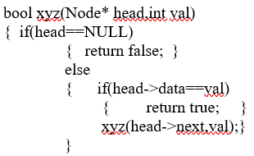
- void insertattail(Node pointer,int val) //pointer=head
{ Node newnode=new Node(val);
if(pointer==NULL)
{ //write logic }
else
{ insertattail(pointer->next,val); }}

Lab Task 3:
- Write a recursive function to find the Nth power P. (For example, Input: Base = 5, Exp = 3)
- Write a recursive function to multiply two numbers. Consider all condition for two numbers.

Evaluation criteria

The evaluation criteria for this lab will be based on the completion of the following tasks. Each task is assigned the marks percentage which will be evaluated by the instructor in the lab whether the student has finished the complete/partial task(s).

Further Reading
The slides and reading material can be accessed from the folder of the class instructor available on lms.

Out comes
The outcomes of this lab were:
- Understand and implement Linear searching
- Understand and implement Binary searching
- Understand recursion

